Online Group Meeting – Project Discussion
Meeting Platform: What’s App
Project Title: CybShield
Meeting Purpose: Project Discussion and GitHub Setup
Date: 12/08/2025

Members Present
✔ Pawan Sunar
✔ Misha Tamang
✔ Yosheph Tamang
✔ Priksha Rawat
✔ Krishna Sah
During the online group meeting, all members discussed the progress of the CybShield project, task coordination, teamwork, and future planning. The group also discussed GitHub setup and project collaboration. One member shared their screen to demonstrate Git and GitHub configuration steps to help the team understand repository management and collaboration.
Overall, the meeting helped improve communication, teamwork, and project organisation among all group members.

Meeting Proof
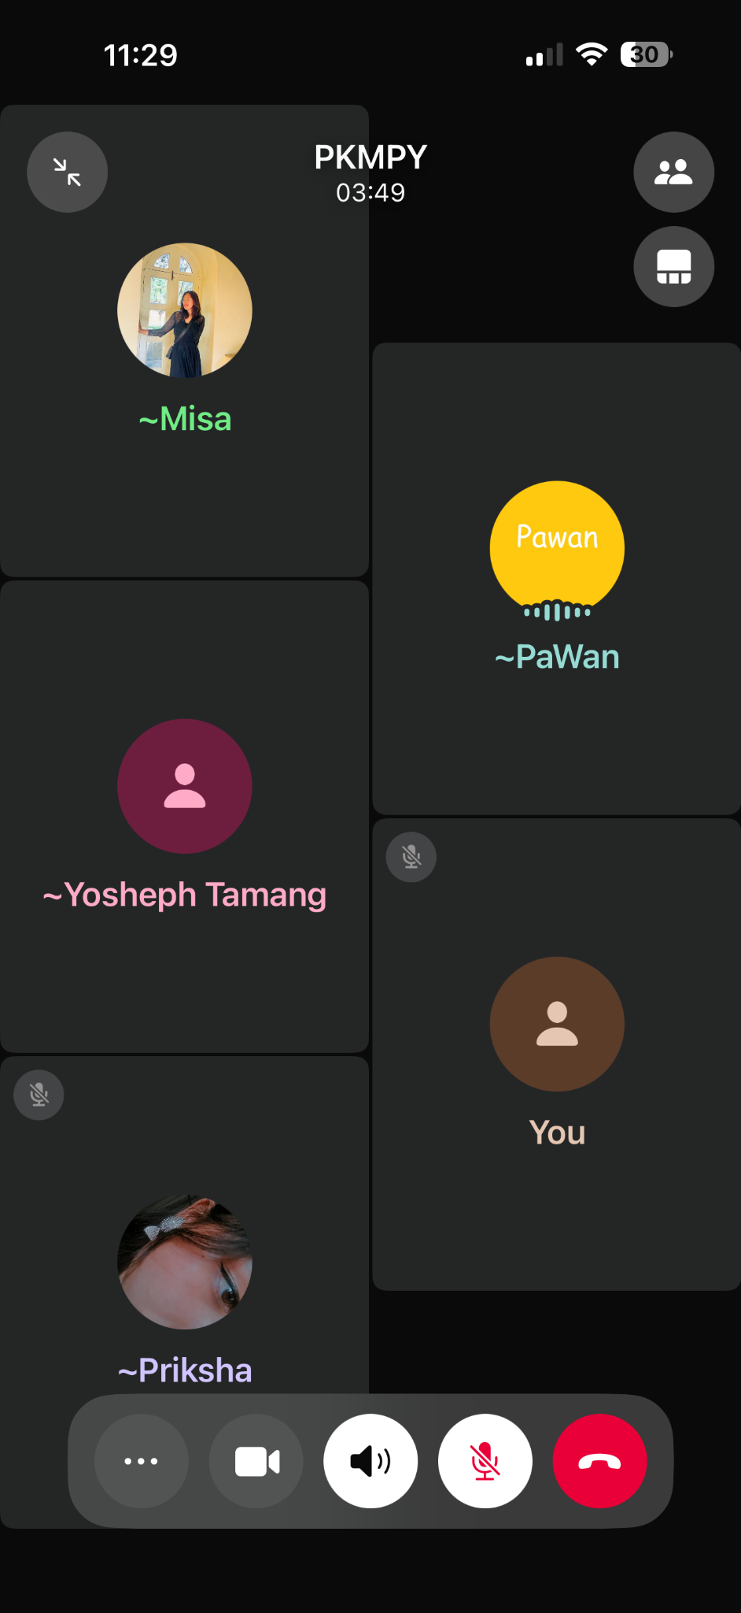
Figure 1: WhatsApp online group meeting discussion.

Figure 2: Screen sharing during GitHub and Git setup discussion.

